**UI Design & Prototyping**

**Excellence Educare (Tuition Website)**

1. Introduction

A React Webapp for a tuition class that offers online education and updates information about the offline tuition classes. The website will serve as an asset for the teachers, where they can upload notes, show the services offered and subjects taught as well as share details about upcoming exams or classes.

Goals

- To create a fully functional react webapp for an education institute.

- To create sections that share details about the institute and other features like uploading and downloading files, listing all classes and displaying media assets.

- To deploy the webapp on a server and submit the application to the institute.

- To be able to render child components for each feature and page.

- To manage the state of the components and the data shared through json files

2. User Interface Design and Prototype

**Wireframe Design (Low-fidelity Prototype)**

**Home (Landing)**

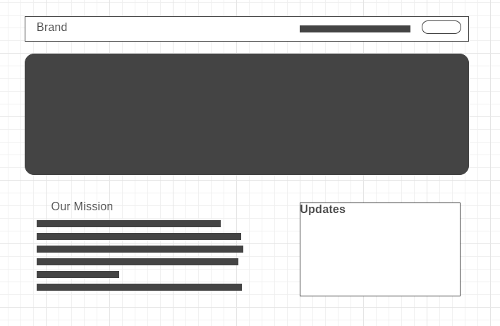

**Courses (With Enrol button on each)**

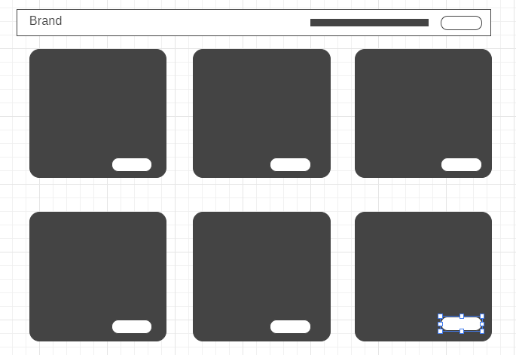

**Events (Gallery in Grid format)**

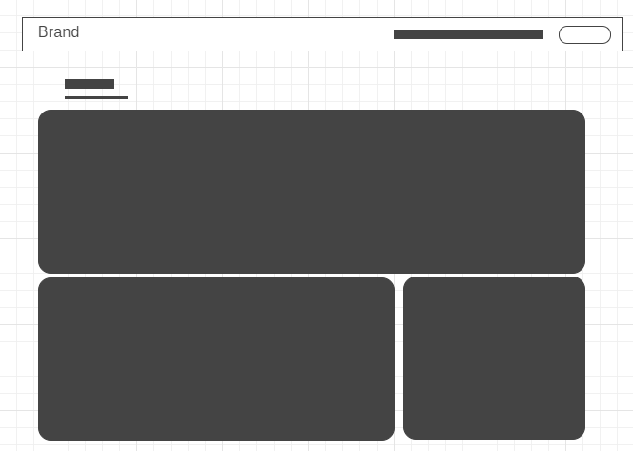

**Academy (With normal business page layout)**



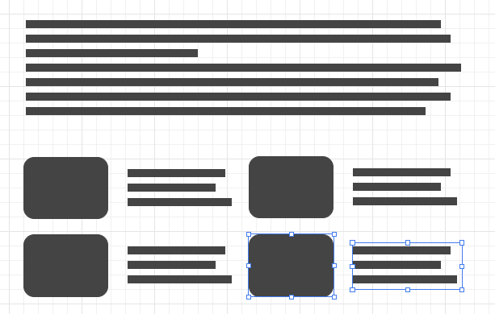

**Contact page (With social media links and business info)**

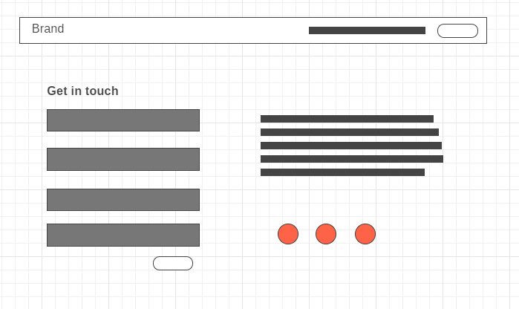

**Rationale**

The UI design is kept simple yet attractive with the core business pages rendered following the same design pattern and colors.

3. Navigation Structure



The Navigation Bar has been created using Material UI with React, this was made with an effort to show the navigation flow

**Key Links-**

1. Home – Main Landing page, will consist of subjects taught, and have a carousel to show the tuition work and classes in progress. The cta (call to action) will be the enrol button
2. Academy – Will have information about the institution, the work conducted, the approach taken and also have out-links to google maps for wherever the tuition classes exist (“Visit Us”)
3. Events – Image Gallery of all the workshops and events conducted by the institute. For example: Football outing, Technical workshop etc.
4. Courses – Encompasses all the courses taught by the academy (Science, commerce, MBA etc)
5. Enrol – The main call to action renders the contact us page where the students or parents can apply to particular courses

4. References

Website references –

<http://shobhasgrouptuitions.in/>

<https://iitianspace.com/>